Mrs. Charters’ Special Schedule

**DAY 1** 

**Gym**

**DAY 2**

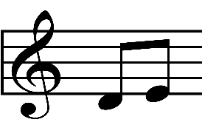

[This Photo](http://commons.wikimedia.org/wiki/File:Musical_notes.svg) by Unknown Author is licensed under [CC BY-SA](https://creativecommons.org/licenses/by-sa/3.0/)

**Music**

**

**Library**



**Day 4**

**QUEST**

**Day 5**

**Art **